1. Copy files in the “var-lib-apt-list” folder into /var/lib/apt/lists folder

Download https://github.com/baosheng0304/PointCloudLib/tree/main/var-lib-apt-lists

2. open terminal in “pip3-packages” and install pip3

sudo dpkg –i *.deb

3. open terminal in “var-cache-apt-archives “ and install all packages

Download https://github.com/baosheng0304/PointCloudLib/tree/main/var-cache-apt-archives

sudo dpkg –i *.deb

if fails, run this command and dpkg again and again until error will be disappeared.

“sudo apt install –f”

and unzip user-local.zip and copy all folders to /usr/local

4. install (this has already been done using internet)

install protobuf

install eigen3

install boost

install PCL

install libusb

install opencv 4.5.5

install NPLOT

install G2O

install ZCM

install libelf

install libgps-dev

install nlopt

5. in “protoc” folder, run below command or run generate_proto.sh

protoc ./detection.proto --cpp_out=./

6. copy all files from “user-include-python3.8” to “/usr/include/python3.8”

7. copy folders from “user-include-x86_64-linux-gnu” to “/usr/include/ x86_64-linux-gnu/”

8. copy folders from “user-include” to “/usr/include/ ”

9. go to “tools/build/resources/ZeroCM/” and run “chmod +x ./waf”

python3 zcm/python/setup.py bdist_wheel

if you get this error, please change code

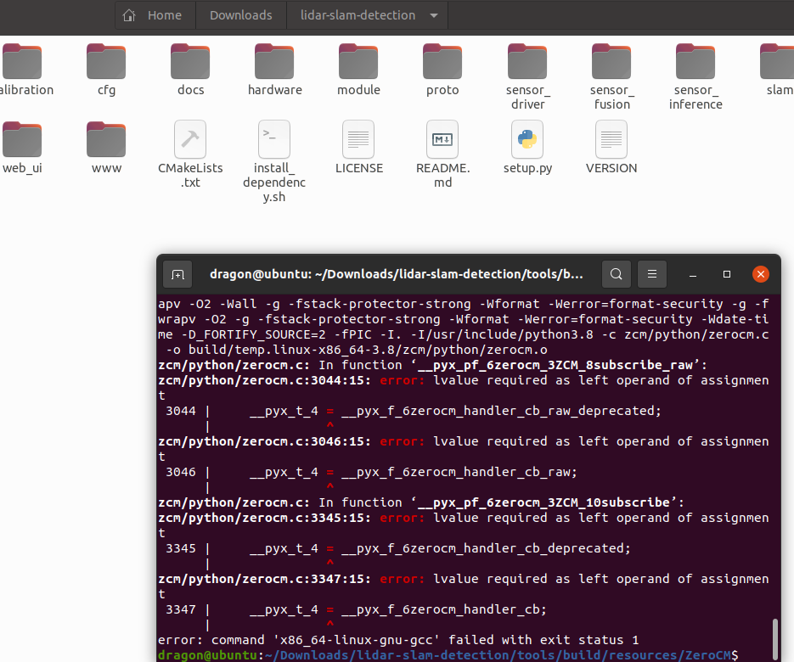

Open zerocm.c file and change code like below image

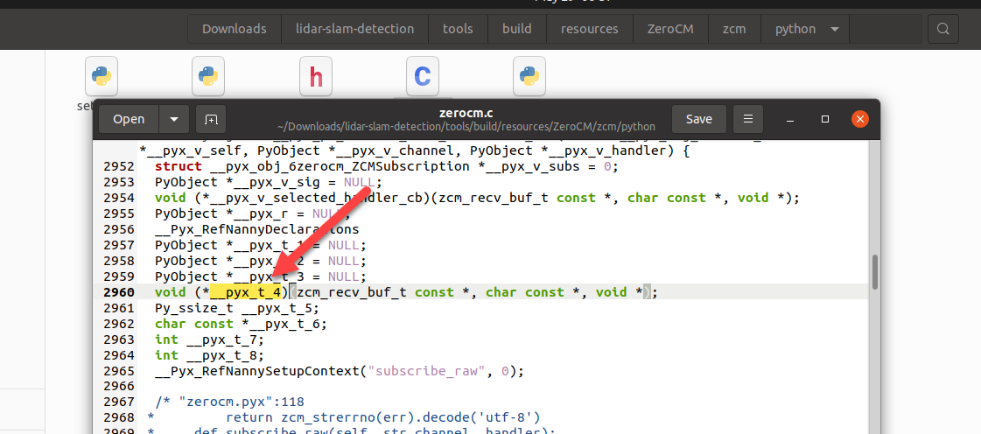

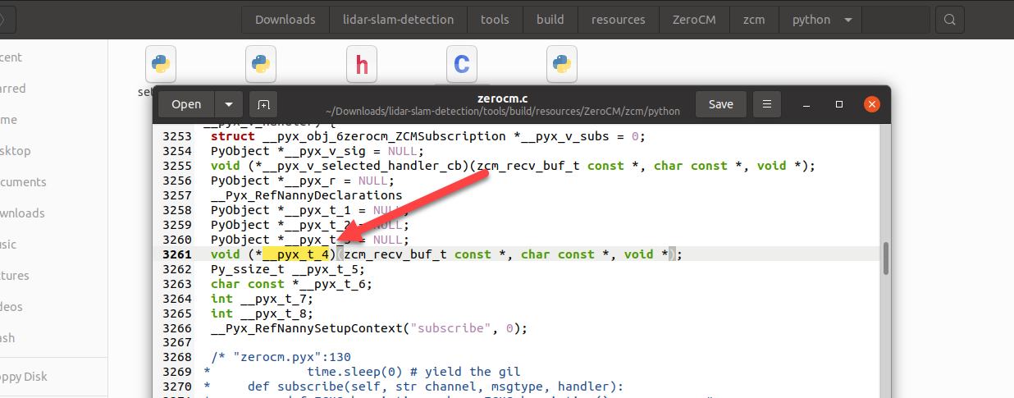

pip3 install dist/zerocm-1.1.5-cp38-cp38-linux_x86_64.whl

10. go to “tools/build/resources/ZeroCM/scripts” and run these commands

sed -i 's/\r$//' prepend-embed-guards.sh

and remove first 3 lines in “wscript” file(I already did, but remove if “/* …. */” string exists).

11. run install_dependency.sh to install ZeroZCM in root folder “lidar-slam-detection”

sed -i 's/\r$//' install_dependency.sh

chmod 777 install_dependency.sh

sudo ln -s /usr/bin/python3 /usr/bin/python

pip3 install --user future-1.0.0-py3-none-any.whl (this is in “python packages” folder)

bash install_dependency.sh (if all has been installed in usr/local/lib, it will be skipped)

12. change these files

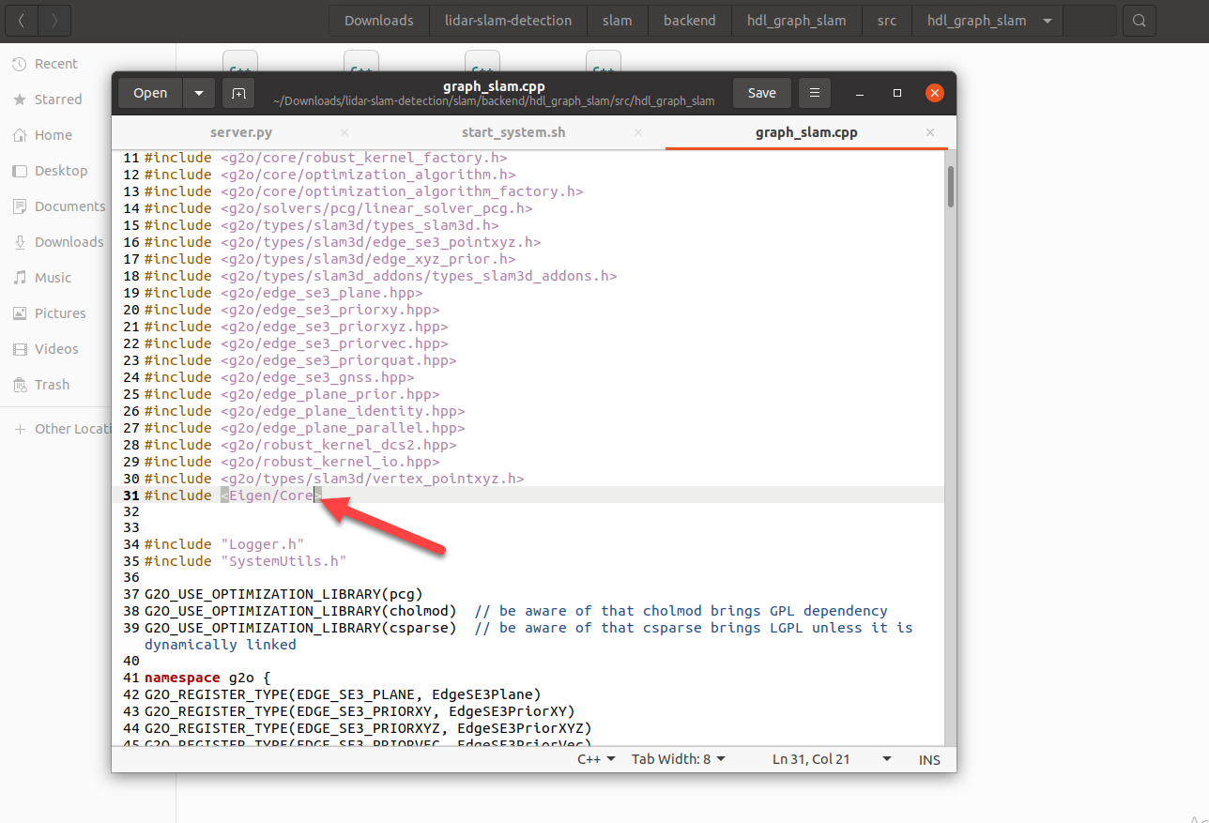

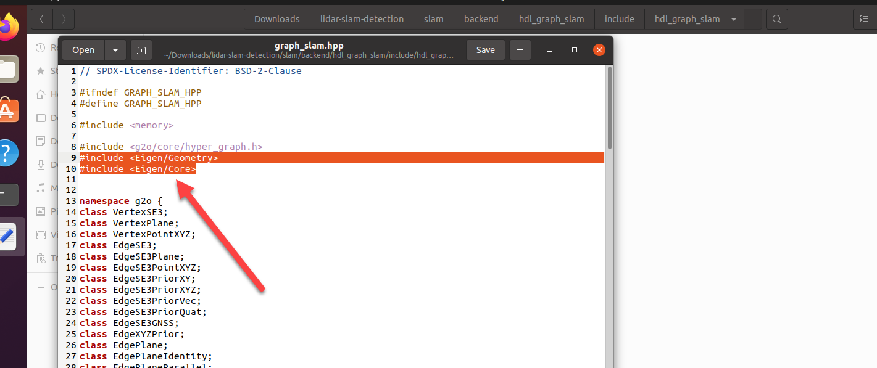

9. build source code

In root folder, run these commands.

unzip slam/data/ORBvoc.zip -d slam/data/

sudo python3 setup.py install

sed -i 's/\r$//' sensor_inference/pytorch_model/export/generate_trt.sh

bash sensor_inference/pytorch_model/export/generate_trt.sh

sed -i 's/\r$//' tools/scripts/start_system.sh

Go to “python packages” folder and install packages

pip3 install zerorpc-0.6.3-py3-none-any.whl --no-index --find-links '.'

pip3 install Flask-2.2.5-py3-none-any.whl --no-index --find-links '.'

pip3 install Flask_Cors-5.0.0-py2.py3-none-any.whl --no-index --find-links '.'

pip3 install json_rpc-1.15.0-py2.py3-none-any.whl --no-index --find-links '.'

pip3 install easydict-1.13-py3-none-any.whl --no-index --find-links '.'

pip3 install opencv_python-4.11.0.86-cp37-abi3-manylinux_2_17_x86_64.manylinux2014_x86_64.whl --no-index --find-links '.'

pip3 install shapely-2.0.7-cp38-cp38-manylinux_2_17_x86_64.manylinux2014_x86_64.whl --no-index --find-links '.'

pip3 install colorlog-6.9.0-py3-none-any.whl --no-index --find-links '.'

change code like this

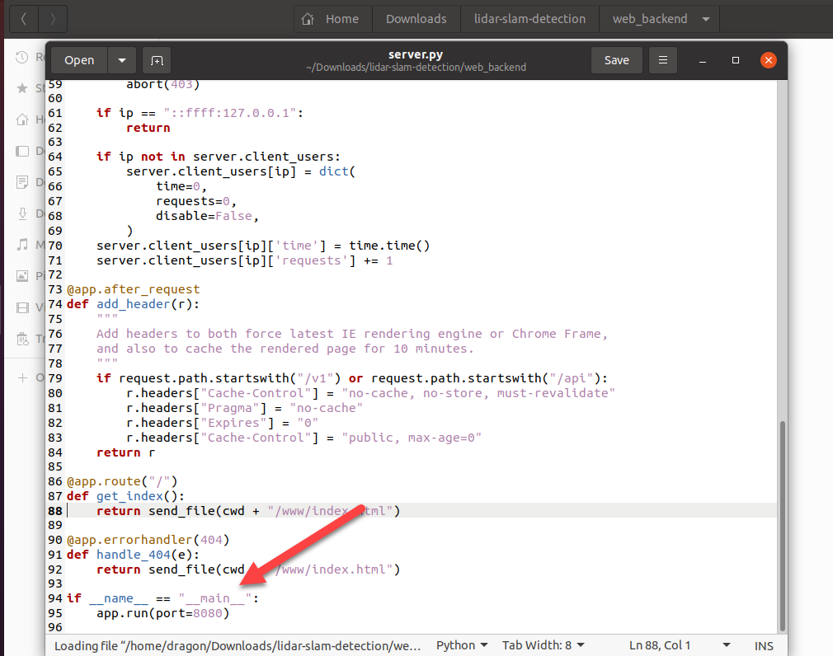

Go to root folder and run

bash tools/scripts/start_system.sh